Standard Operating Procedure | Simulation Based Education
Target Audience: | Education Team, Delegates and Wider Faculty
Document Reference: | BHT Sim 2022
Version: | 1.0
Prepared by | BHT Simulation and Clinical Skills Team
Effective Date | 1st January 2023
Review Date | 1st January 2026
Approvals | ELDI Senior Team
Uploaded to Intranet

Introduction

Simulation is a growing field in healthcare education, with a convincing evidence base, demonstrating its benefits. Today’s healthcare educators use simulation techniques rather than traditional lecture-based learning, to create clinical situations, through the development of real-life scenarios and the use of healthcare manikins. During the simulation learners will develop, practice and refine their skills in a safe learning space, with no risk to patients or impact on service delivery.

The Simulation & Skills Team at Buckinghamshire Healthcare NHS Trust coordinate the delivery of over 200 courses a year training in excess of 2000 staff. The service offers training to clinical areas and professional groups across the Trust’s hospital sites.

Purpose

The intended use of this SOP is to aid in the delivery of training by the Simulation and Skills Team in giving structure to the design, and delivery of simulation-based education (SBE) activities. The aim of this SOP is to allow SBE training to be compliant with agreed best practice guidelines (ASPiH Standards) in order to produce quality assured teaching. This SOP will create an informed review process for teaching programs and allow for streamlined collaboration with professionals and partners that access this service.

Scope

This operating procedure covers the following activities:
- SBEs within a training environment.
- Insitu SBE within clinical departments.
- SBEs at external non-BHT venues.

Simulation Activity

The Simulation & Skills Team will hold data that is required for reporting to Higher Education England (HEE) and NHS England (NHSE). This data will correspond to attendance, feedback, consent to recording and a record of skill competence. Only the minimal required data will be held within the department, and it will be anonymised where possible. This data will be kept in line with BHT Policy 220. (BHT Pol 220 / IG0069: Guidance on Information Disclosure and Sharing Decisions (Including giving information to the police).

Simulation Activity can be categorised into two groups:
- Learning that is required for staff to work within their role
- Learning that is supplementary to their role

Courses in the first category make up the service’s business as usual courses and are needed for divisions to provide clinical services. Supplementary courses are simulation events that aid in learners personal and professional development. The Simulation & Skills Service will report its activity to the SMC & EMC on a quarterly and annual basis through existing education reporting processes.

Quality Assurance

Simulation Based Education within Buckinghamshire Healthcare NHS Trust will uphold a national standard of SBE and be an active member in the simulation community to enhance the standard of SBE within the Thames Valley Region. This will be informed by the regional network for simulation (SimNet-TV) and national bodies such as Association for Simulated Practice in Healthcare (ASPiH). The Simulation & Skills Team will actively engage with the development of new standards and disseminate information to faculty and learners within the Trust.

In order to safeguard the quality of training delivered the Simulation & Skills Team will outline the standards for best practice as recommended by the ASPiH for faculty and learners (ASPiH standards 2019) and these include the following:
- Course Delivery
- Simulation Faculty
- Debriefing
- Learners
- Psychological Safety

Course Delivery
In order to meet the guidance and standards within this document SBE events require a significant amount of preparation and planning. This process is outlined within course design section of this document. If the minimum requirements are not met by either the Simulation Faculty Course Lead or Simulation & Skills Team the Simulation Faculty Lead may cancel the SBE training session. This decision will be based upon the impact to the learners and safety of patients.

  - Simulation Faculty
Simulation events need appropriately trained faculty in order to produce an effective learning experience that does not negatively impact the learners and the environment. Faculty are recruited by from a pool of subject matter experts that may have limited previous experience of SBE as an educational method. All faculty will be expected to act in a manner which is compliant with the BHT Policy 032 (BHT Pol 032 Standards of Behaviours and Conduct Policy & Procedure). Simulation Faculty at BHT should engage in quarterly simulation faculty meetings to keep informed in any changes in simulation & clinical skills guidance. To achieve the standard of excellence set out by national guidance the simulation faculty must adhere to the training requirements and regulation as laid out in the ASPiH standards. Simulation Faculty can be categorised as:

- Novice
- Experienced

Novice simulation faculty can be defined as subject matter experts that have not taken part in SBE or have never received formal SBE or debriefing training. These may be members of staff that have identified a training need within their department or educators that have not used SBE as a teaching methodology.

In order to support novice faculty, the Simulation & Skills Team will continue to improve upon the training pathway so that it is accessible. The faculty development program should always allow faculty to achieve the fastest route to being able to deliver quality SBE. Novice Faculty must attend a simulation faculty development program & Human Factors Training which is agreed on by the Simulation & Skills Faculty Lead. Following this, novice faculty will enter the peer feedback review process. Peer feedback observations will continue for each simulation course that they facilitate allowing for the additional support and mentorship that they may require. Once novice faculty have achieved a score of 3 or higher in each section using the Peer Feedback Assessment Tool (Appendix 6 ) , they will be able to exit the mentorship process and become experienced faculty members.

Experienced faculty can be defined as, novice faculty that have achieved a score of 24 or more or simulation faculty that meet the training requirements and having existing experience delivering simulation programs. These experienced faculty members will then enter an annual peer feedback process whereby; a peer feedback observation will take place during one of their courses within a 12 month period. If a score of 3 in each section is not achieved, then they will enter the mentorship process outlined in the novice faculty pathway. This will allow for them to take part in individualised feedback and create an action plan to improve upon their skills as a debriefer. This may include additional training courses in human factors or simulation debriefing.

It is the responsibility of the Simulation & Clinical Skills Team to keep and maintain a record of the training for both Novice and Experienced faculty members and their feedback. If a member of staff has evidence of simulation training they may enter directly into the experienced pathway at the discretion of the Simulation & Skills Faculty Lead. The BHT Simulation & Clinical Skills Team will notify faculty regarding their faculty development and their peer feedback process and will contact faculty directly to organise their observed sessions.

  - Peer Feedback
A peer feedback process will be adopted by all simulation facilitators. This observation can be undertaken by an experienced faculty member during the debrief of a scenario, in the case of a simulation event with multiple scenarios the assessor may choose to observe multiple debriefs. The feedback will be delivered confidentially following the conclusion of the course or simulation scenario as well as the result of the feedback e.g., staff moving from the Novice to Experienced Faculty category.

  - Debriefing
It is understood by this document that debriefing has many formats, the scope of this SOP specifically pertains to simulation-based debriefing. It is nationally recognised that simulation faculty must have received training that concentrates on debriefing and should embark on a lifelong journey of development and feedback on their debriefing effectiveness.

Debriefing is accepted to be the most valuable part of the simulation activity and it is where the largest part of learning can be imparted, therefore it is very important that faculty are appropriately skilled to deliver this to learners. For faculty to debrief a simulation event they must undertake the training needed as outlined in the Novice development pathway. Untrained members of faculty undertaking a simulation debrief may negatively impact the clinical and psychological performance of their learners. It is recommended that debriefers utilise a model of debriefing and the BHT Simulation & Clinical Skills Team have developed the DDA debriefing tool to aid new faculty members (Appendix 7 ).

  - Learners
The BHT Simulation & Clinical Skills Team value the psychological safety of its learners. As such, learners should not discuss events that happen in simulation as these are confidential and are in keeping with the ethos with a psychologically safe environment. As simulation is used to learn in an experiential way any simulation practice that is not being used as an assessment will remain confidential and will not be disclosed outside of the training event. Due to this, each learner is expected to conduct themselves in line with the Trusts values and in keeping with their professional registering body.

Learners are expected to arrive to their session on time, give adequate notice to the faculty if they are late or cannot attend and should have completed any prior learning before arriving at their simulation or skills session. Learners will be asked to enter into an agreement not to discuss simulation scenarios with other staff members to allow teaching content to remain original.

Feedback is vital for the improvement of courses and teaching programs. Learners will be asked to complete feedback at the end of the session. Learners will be asked if they wish to be recorded or photographed for course promotion material prior to the start of the simulation. Some events will mandate the recording of sessions for skills assessment and this will be explicitly explained at start of each training event or program. This information is then held locally according to the BHT Policy 220.

  - Psychological Safety
Debriefing will be conducted in an environment which is safe, inclusive and constructive. Any feedback should be delivered in a non-threatening and developmental manner. Faculty should communicate in a way which fosters a feeling of trust, respect and confidentiality. At the beginning of all simulation training activities Faculty and learners will both agree to an understanding that ‘everyone participating in simulation and training activities are intelligent, capable, cares about doing their best, and wants to improve.’ (Harvard Center for Medical Simulation 2022)

In order to create an environment that is psychologically safe the BHT Simulation & Skills Team will adopt the following principles:

- All leaners and faculty will respect the contribution of all participants.
- Learners will be invited to share their clinical experiences within simulation training, but it is not a requirement.
- Conversations that occur within the simulation debrief will be confidential between faculty and learners.
- During simulation activities learners will be directed to services for their health and wellbeing, as necessary.
- Adhere to BHT Policy 090 (BHT Pol 090 Psychological Wellbeing in the Workforce)

Patient Safety

It is the main purpose for SBE is to improve patient safety, this can be achieved through:

- Improving Patient Experience
- Improving staff wellbeing
- Improving Staff skills
- Improving systems & patient pathways

  - Insitu Simulation
A proportion of the service that the BHT Simulation & Skills Team provides will be Insitu. This is when simulation education takes place within a ‘live’ clinical environment during normal operating hours. This service is intended to increase the fidelity of the learning and increase the participation of teams that work within BHT. This service will be held to the same standards that are described previously in this SOP. However, some additional considerations need to be made to promote psychological safety and confidentiality in a clinical setting. Simulation occurring within a clinical space will need to be identified and a suitably confidential debriefing space will need to be available.

The safety of clinical patients will always take precedence when considering if an Insitu simulation should occur. The Infection Control exposure risk to education teams and equipment must also be considered when running events and adequate time must be given to allow for decontamination.

Operational pressures should also be considered when assessing the suitability of an Insitu simulation. The Simulation & Skills Team will closely communicate with clinicians leading the clinical area before starting to prepare for a simulation event especially during times of high operational pressures.

  - Human Factors
A common outcome of SBE is developing a team’s non-technical and leadership skills. There is an understanding that Human Factors contribute to the reduction of error and risk management within healthcare and the Simulation & Skills Service is often involved in the learning from such critical incidents. In view of this the Simulation Faculty will be encouraged to attend Human Factors training provided by the Simulation & Skills Team. The Simulation & Skills Service are committed to providing Human Factors training for clinical teams within BHT and faculty providing Human Factors training must have attended a suitable Human Factors trainer program.

Course Design & Review Process

  - Design
Simulation courses should be designed with the learner in mind. Once the need for a new course has been identified a meeting should take place between clinical stakeholders and the Simulation & Skills Team. This meeting should outline the content of the training program and the equipment required to run a simulation or skills event. A template of this meeting is held within this SOP (Appendix 3). At the initial planning stage, the faculty should explore the possibility of making the training Multi-Professional and should agree the course learning outcomes. It may be decided that Standardised Patients (actors) may be utilised for an SBE event, for these courses the Association of Standardized Patient Educators (ASPE) Standards must be observed.

Within this SOP is a protocol for the creation of a new program from design to delivery which should act as a guide for the development of a new simulation course (Appendix 1). Due to the time required to develop and produce a simulation training program a start date may not be issued at the initial request (Appendix 2). The Simulation & Skills Team recommend a structure of SBE which allows for faculty and learners to be adequately prepared for the training event (Appendix 4).

Existing simulation programs will be expected to adhere to the following standards:

- A course timetable should be released one month in advance to the SBE event which has allocated members of faculty to allow the Simulation & Skills Team to appropriately allocate staffing resource.
- Scenarios must be agreed 2 weeks prior to the SBE event to allow for specialist & consumable equipment to be sourced.
- Resources required to run the SBE will be sourced and checked in advance to the SBE event.
- Minor scenario adjustments can be made up to the day of the event but will be finalised by the SBE team brief.
- A minimum threshold of participants should be agreed in the event of low attendance.

  - Review
All educational programs should be reviewed to adapt to the changing needs of the learners, clinical evidence and simulation technologies. SBE programs will be reviewed after each individual running of a course and on a 12 month basis at a minimum. This will allow the faculty to review feedback from delegates and updates to clinical policies which will allow constant improvement of the quality of SBE courses. Annually Simulation & Skills Educators will meet with Faculty Leads to review the effectiveness of the training program and complete the Course Annual Review Form (Appendix 5). This will give the faculty the opportunity to assess the continuing need for training whilst adapting the planning and delivery of courses. This meeting also gives faculty leads and the Simulation & Skills Team to succession plan for faculty and discuss additional support for their debriefers.
Appendix 1 - Simulation & Skills Course Development Cycle
Appendix 2 – Course development Pathway
Appendix 3 – Simulation Course Meeting Template
Appendix 4– Recommended SBE event structure
Appendix 5 – Course Annual Review Form
Appendix 6 – PFAT: Peer Feedback Assessment Tool (based on The Observed Structural Assessment of Debriefing Tool)
Appendix 7- DAA Debriefing Tool

Appendix 1-Simulation & Skills Course Development Cycle

Appendix 2
Appendix 2- Course Development Pathway

Appendix 3- Simulation Course Meeting Template

Course Contact | Name, profession, contact information…
Course Date | Date and time of event...
Learners | Number of attendees, profession…
Scenarios | Brief outline of each scenario…
Specialist Equipment or disposables | Specialist kit & disposables e.g. A-line sampling trainer and syringes.
Faculty | Names and contact info for key faculty…
Presentations | Who will hold the presentations?
Action Points

Appendix 4 – Recommended SBE event structure

Appendix 5 – Course Annual Review Form

Course Name | Overview | Challenges | Successes | Evaluation / Feedback | Actions / Plan for the next year | Course Contact | Numbers of Courses/ attendees
example  Managing Airways For Nurses in Critical Care (MANICC) | Recognition and management of simulated ICU patient problems with airway (faulty cuff and obstruction) DAS trolley and guidelines, intubation, cricoid pressure, use of intubation checklist etc. Face to face teaching/Sim scenarios | Pressures to release staff from ICU and difficulty having appropriate faculty to run the course. | The simulation has managed to overcome the difficulties in ventilating the manikin creating a more realistic experience for learners. | 98.33% feedback score on iFeedback | Continue attempting to expand this course to areas outside ICU such as Recovery and ED. Attempt to catch up with the backlog of ICU existing and new staff. | Tahir Ali  tahir.ali2@nhs.net  Tracy Hadcroft  tracy.hadcroft@nhs.net | 4 courses ran  Training 24 staff

Appendix 6 - PFAT: Peer Feedback Assessment Tool (based on The Observed Structural Assessment of Debriefing Tool)
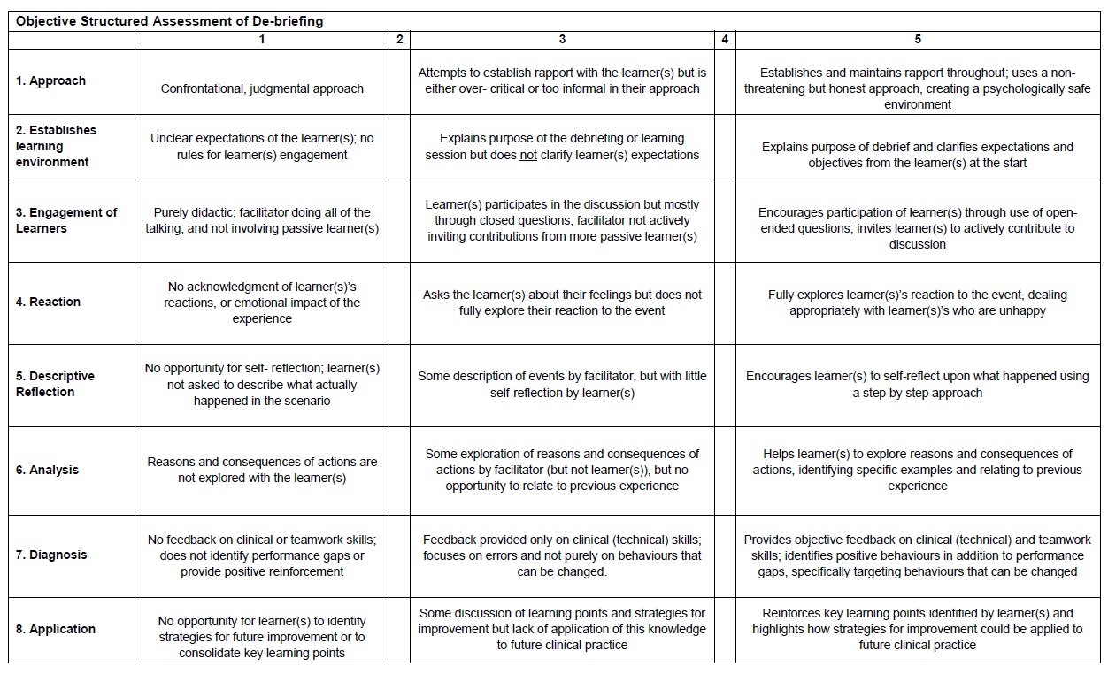

Additional Comments
Action Plan for development
Name of Facilitator | Name of assessor
Date | Overall Score

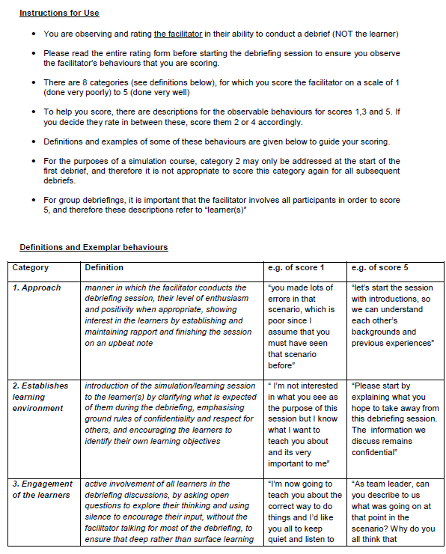

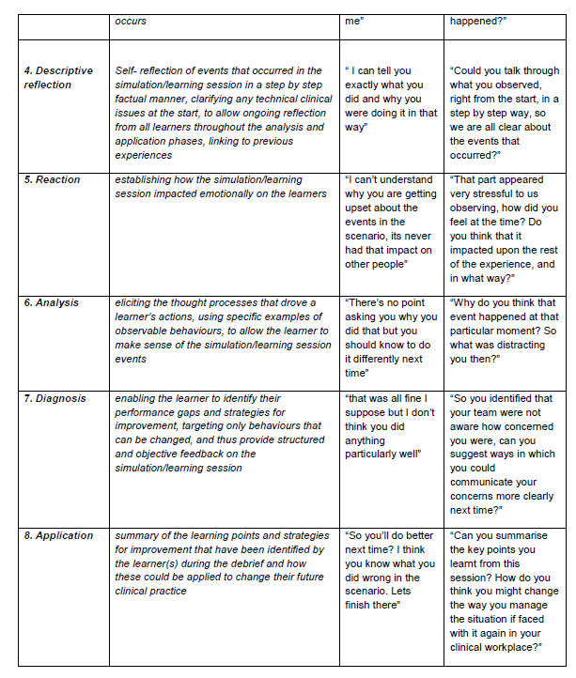

Appendix 7- DAA Simulation Debriefing Tool
D  Description | Reactions:  “How do you feel?...”  “Why do you think you feel that way?”  Descriptions:  “Can you tell us about what happened from the beginning...”  Collect facts, probe the story  Close Description with:  “The Scenario was designed to explore…”  Open to the group
A  Analysis | Highlight the topic for discussion.  “So you have mentioned..”  “This is an important topic which I would like to talk about further…”  “What is your experience in practice around this area…?”  “Why?” “How?”  Use open, clarifying questions. Probe, explore.  Boomerang points back to the individual  Open to the group
A  Application | Summarise  “I hear…”  “You mentioned…”  Reflect  “What would you do differently in practice?”  “How might you address this in practice?”
Other Comments | “Thank you - Any other final points?”

